**No. AP19174774 «Study on the impact of underground mining on surface social facilities» - s.s. N.R. Huanggang**

***Relevance***

Ore mining by the room-and-pillar system is one of the most efficient. Significant disadvantages of the technology used are ore losses in pillars left to support the mined-out space (voids), accumulation of voids and their collapse after the destruction of pillars due to a long service life (decades). Sudden collapses of mined-out spaces over large areas are accompanied by man-made earthquakes.

In 1996, after a number of major collapses accompanied by earthquakes, a new concept for further efficient and safe development of the Zhezkazgan deposit in the existing mining and geomechanical conditions was developed, agreed upon with the committee of the state mining and technical supervision of the Republic of Kazakhstan, and approved by the minister of industry and trade of the Republic of Kazakhstan. It set out three fundamental provisions, in accordance with which the industrial exploitation of the deposit would be completed: 1) to develop the remaining balance reserves using the room-and-pillar system, for which, in the conditions of Zhezkazgan, there is no acceptable alternative for mining ore of run-of-mine and lower value; 2) simultaneously with the primary development of the remaining balance reserves, to conduct repeated development of previously abandoned pillars with the return of ore from losses; 3) during repeated development, to extinguish the accumulated voids by controlled self-caving of the overlying stratum.

The main objective of the project is to assess the seismic risk in the area of ​​the village of Zhezkazgan as a result of the impact of mining operations.

The influence of underground mining operations during the development of ore bodies and/or abandoned inter-chamber pillars on the deformation of the earth's surface with buildings is studied by numerical modeling of the stress-strain state of the massif using finite element methods with the use of the COMSOL and MATLAB application software packages, developed specifically for engineering and scientific research, including in the field of geomechanics.

To assess the impact of underground mining operations on the stability of protected objects, absolute (mm) and relative (mm/m) subsidence of the surface of the displacement trough are used.

Calculations of the rock mass displacement and numerical modeling of the geomechanical state of the undermined sections of the day surface along profile lines will give the values ​​of vertical subsidence. This is a conclusion about possible serious deformations of surface objects falling into the displacement zone, and accordingly - about the need to resettle the residents of the villages of Zhezkazgan and Krestovsky to a safe place.

***Project goal***

The aim of the project is to calculate geomechanical parameters of rock mass displacement and numerically model the geomechanical state of the undermined sections of the day surface along three profile lines showing the values ​​of absolute vertical subsidence of the day surface. This allows us to draw a conclusion about possible serious deformations of surface objects falling into the displacement zone.

***Expected and achieved results***

A numerical method for predicting the magnitude of man-made earthquakes during underground mining in the conditions of the Zhezkazgan ore deposit was carried out:

According to the data of scientists Mossyakin D.V., Makarov A.B., the dependence of the energy class of an earthquake on the area of ​​collapse was obtained (Figure 1).

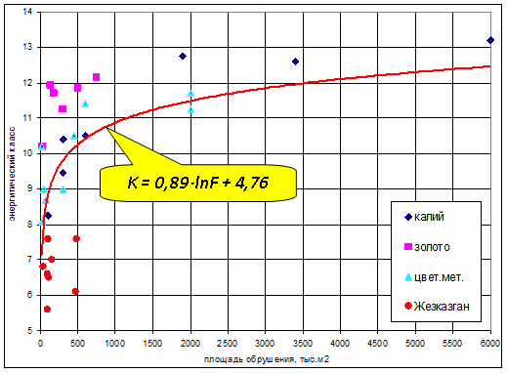

**Figure 1 –**Relationship between the energy class of man-made earthquakes and the area of ​​collapses Mossyakin D.V., Makarov A.B.

A graph of the relationship between the displacement (or shift) of the massif during collapse and the magnitude of the man-made earthquake was constructed and is shown in Figure 2.

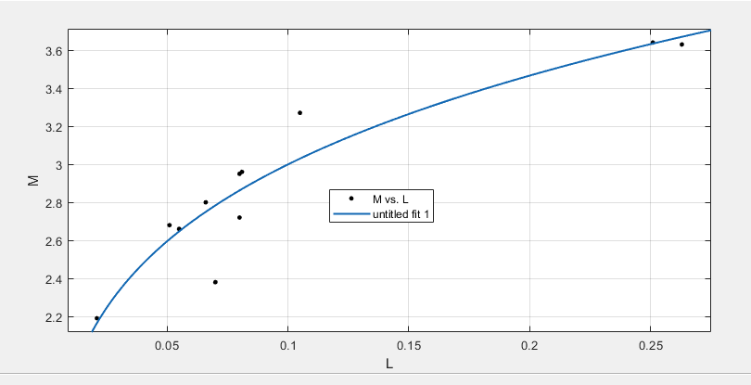

*M*– magnitude of man-made earthquake; L – absolute displacement values, m

**Figure 2 -**Graph of the dependence of the magnitude of a man-made earthquake on the amount of massif displacement

Numerical modeling of the massif's VAT along the profile line No. 32 of the mine No. 31 of the ERA showed vertical subsidence of the trough, shown in Figure 3.

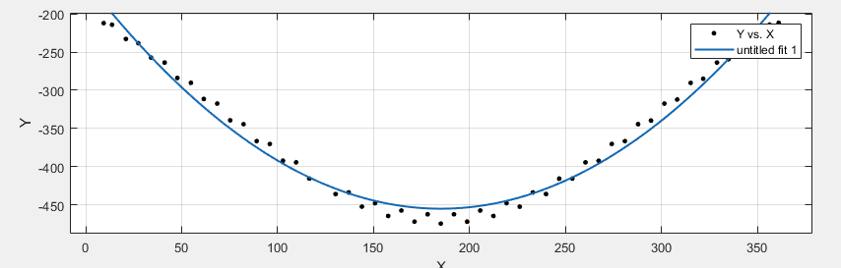

**Figure 3 -**Graph of absolute vertical subsidence (mm) of the trough surface

Calculated by the formula *M*= 4.851 · L0.268 The magnitude of a man-made earthquake caused by a vertical massif subsidence of 0.45 m is 3.95.

Figure 4 shows the calculation scheme of the numerical modeling of the stress-strain state using the finite element method along profile line No. 21 of the samemine No. 31 ERA.

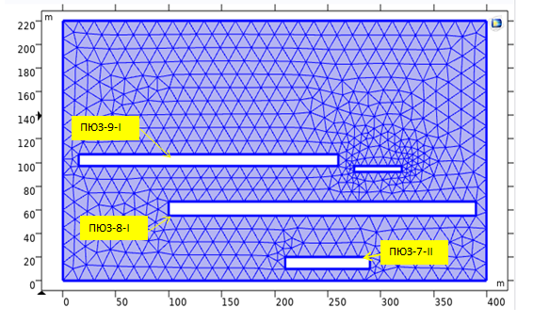

**Figure 4 –**Calculation scheme of the FEM for the section of profile line No. 21

As can be seen from the figure, three deposits are completely removed, which could lead to large massif shifts and a significant man-made earthquake.

*Expected results*

As a result of the project implementation, a methodology for assessing the impact of mining operations on the condition of surface protected objects will be developed. The methodology is implemented using application programs on a PECM and includes the procedure for modeling geomechanical processes, assessing the stress-strain state of the rock mass, and calculating surface displacements and subsidences within the displacement trough.

The methodology will allow technical services of mining organizations to optimize the procedure for conducting mining operations in terms of their planning, taking into account the time factor.

1. At least 2 (two) articles will be published in journals from the first three quartiles of the impact factor in the Web of Science database or having a citescore percentile in the Scopus database of at least 50.

2. At least 2 articles and/or reviews will be published in peer-reviewed foreign and/or domestic publications recommended by CQAES.

3. It is planned to obtain 2 certificates of entry of information into the state register of rights to objects protected by copyright.

***Research group***

Huanggang Nurbol, PhD in Mining engineering, associate professor.

Hirsch Index-5,<https://www.scopus.com/authid/detail.uri?authorId=57191875943>, <https://orcid.org/my-orcid>

Author ID in Scopus: 57191875943

ORCID ID: 0000-0001-9609-6649

Assainov Sergey Tursunovich, Ph.D., senior lecturer, department of DMDD

***List of publications***

1 Article in the journal included in the CQAES database (Huanggan Nurbol, Assainov Sergey Tursunovich, Shakhatova Aliya Talgatovna. «Geomechanical assessment of the impact of mining of an excavation site on the state of underground geomechanical structures» Proceedings of the University No. 3 (92) 2023, Section «Geotechnology. Life Safety», pp. 213-219 DOI 10.52209/1609-1825_2023_3_213,).

2. A certificate of state registration of intellectual property rights was received (Certificate of entering information into the state register of rights to objects protected by copyright No. 39404 dated October 4, 2023 (authors Huangang Nurbol, Assainov Sergey Tursunovich).

3. 1 Article was published in a journal included in the scopus mining of mineral deposits database (B. Tolovkhan, A. Smagulova, N. Khuanggan, S. Assainov, S. Issagulov, D. Kaumetova, B. Khussan, M. Sandibekov. «Studying rock mass jointing to provide bench stability while Northern Katpar deposit developing in Kazakhstan» Mining of mineral deposits. ISSN 2415-3443 (Online) | ISSN 2415-3435 (Print) Volume 17 (2023), Issue 2, 99-111.<https://doi.org/10.33271/mining17.02.099>).

4. A certificate of state registration of intellectual property rights was received (Forecasting the impact of mining operations on the processing of reserves on the condition of geomechanical structures and surface facilities - No. 42698 dated February 7, 2024 (author Huangang Nurbol).

***Information for potential users***

An analytical report has been compiled based on the results of geotechnological studies on the physical and mechanical properties and structural features of the rock massif. Multiple geological characteristics of the Zhezkazgan deposit.

A database of physical and mechanical properties of ore bodies and host rocks has been compiled. The influence of mining and geological and mining-technical conditions of deposit operation on the parameters of underground mining operations during the development of ore bodies.

The obtained research results will allow us to draw reasonable conclusions about the possibility or impossibility of conducting underground mining operations in specific areas of the deposit.

***Scope of application***

Mining enterprises engaged in the development of minerals using underground methods.

*Date of information update: 08.11.2024*